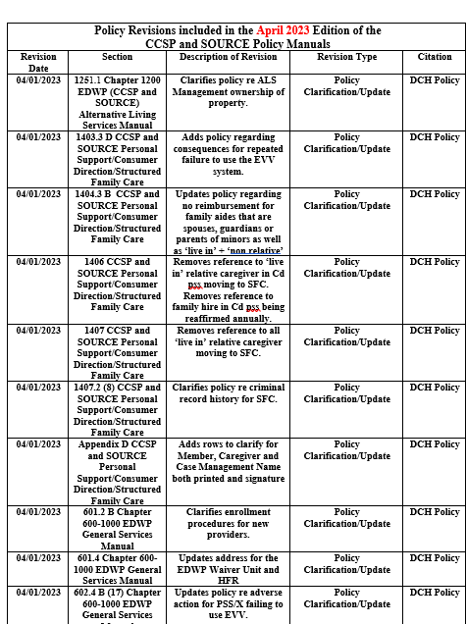
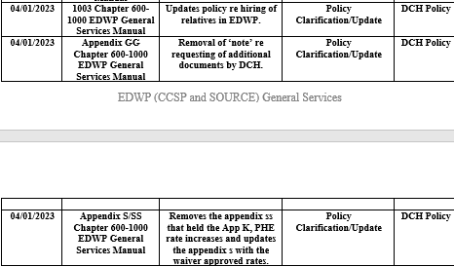

1251.1 ALS update this jill re wording
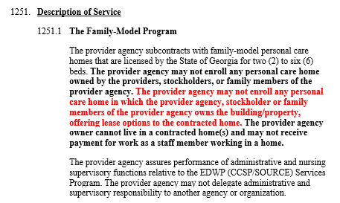
1403.3 D Consequences for repeated failure to use the EVV system for PSS providers.

1404.3 B NOTE
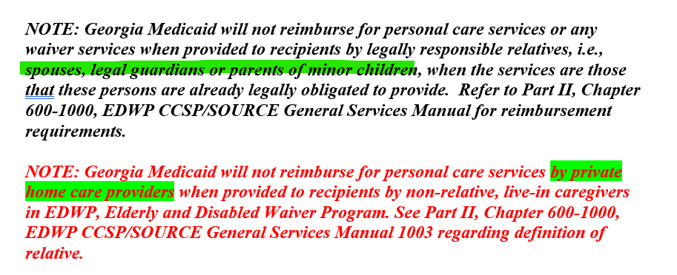

1406/1407 PSS
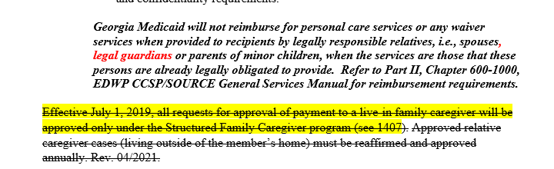

1407.2(8) PSS
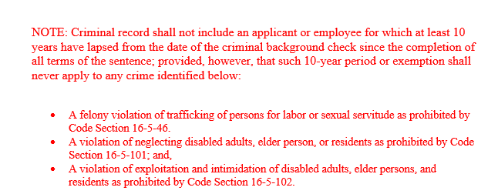

601.2 B
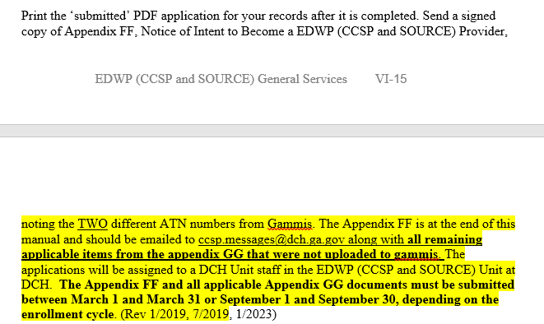

601.4
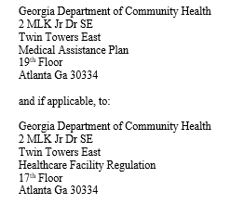
602.4 B (17) Gen Services Manual
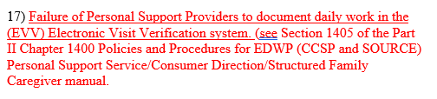

1003 Gen Service Manual
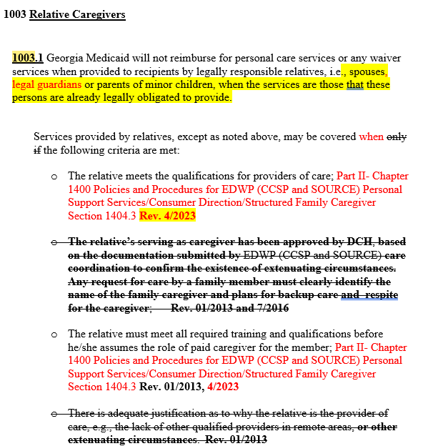

1003 Gen Service Manual- CONTINUED

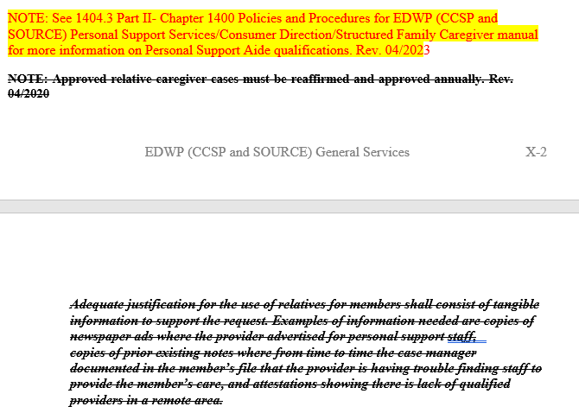
Appendix S/SS
Removes Appendix SS, the PHE temp rate increase and updates Appendix S with the new rates.

CCSP CASE MANAGEMENT MANUAL
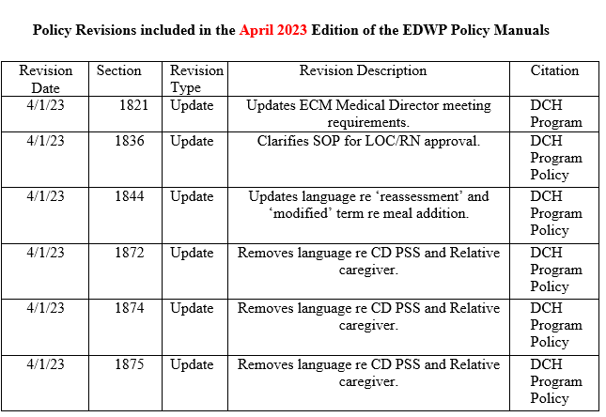

1821
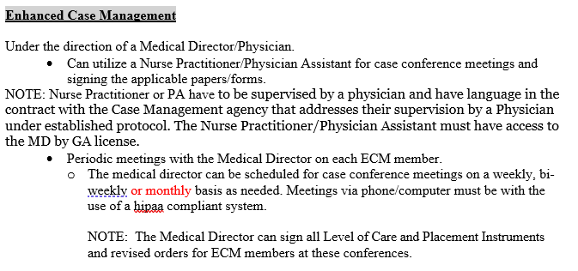

1836

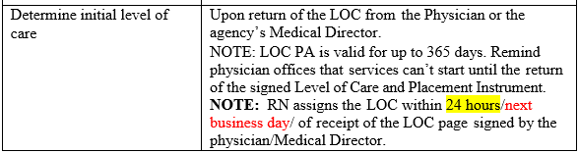

1844

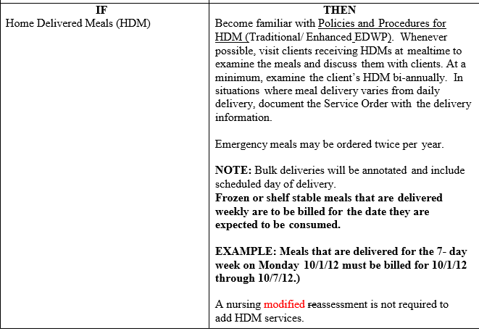

1872, 74 and 75
Removes language in CD PSS re prior and annual approval for relative caregiver requests. Will remove #34 policy document from gammis, family caregiver request.

