WAIVER | WAIVER Specialist
EDWP Provider Specialist  ICWP Lead | Vonnie Stelly  VStelly@dch.ga.gov 470-542-9402
EDWP Case Management Specialist  CCSP Lead | Jill Crump  Jill.Crump@dch.ga.gov 404 357 0161
EDWP Case Management Specialist  SOURCE Lead | Carolyn Porter, RN  Carolyn.Porter@dch.ga.gov 404-859-2675
EDWP Provider Specialist  (waiver enrollment, changes, updates, buyouts etc) | Korey James  korey.james1@dch.ga.gov 470 580-2677
EDWP changes/questions/ALS F Registrations | ccsp.messages@dch.ga.gov
GAPP | Sharon Collins  scollins@dch.ga.gov
Director, Program and Community Support | Rebecca Dugger  rdugger@dch.ga.gov
PA Management/Claims Resolution | Donna Elrod  Donna.elrod@dch.ga.gov 470-522-9620

____________________________________________________________________

The Georgia Department of Community Health, HCBS Waiver incident reporting system:

The HCBS Incident Report can be accessed at -

HCBS Incident Reporting System | Georgia Medicaid

Additionally, we have a resources page to assist in training agency staff.

Link to resource page:
https://medicaid.georgia.gov/programs/all-programs/waiver-programs/hcbs-incident-reporting-system-resources

For questions or technical assistance, please reach out to the HCBS Waiver Unit at: HCBS.IncidentReports@dch.ga.gov.

Other Contacts

- DXC, 1-800-766-4456

- Provider Enrollment enrollment@dch.ga.gov

- Revalidation, revalidationenrollment2@dch.ga.gov

- CVO, 1 800-766-4456 outreachsupport@verisys.com

- Gainwell- Gainwell Field Representative assistance- GAMMIS website, www.MMIS.georgia.gov, select Contact Information tab, then Contact Us tab. Choose the applicable drop-down from the list. Call 800-766-4456.

Finding a list of active medicaid providers in Ga
https://dch.georgia.gov/ click on ‘providers’ and ‘provider directory’

HFR Contact Information-

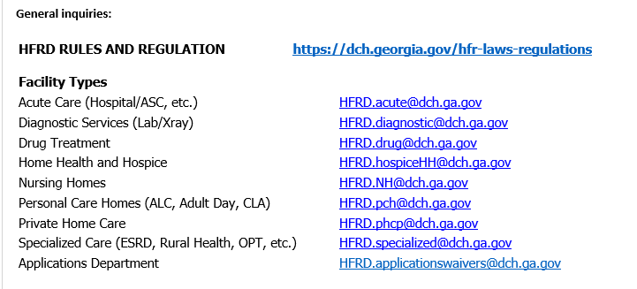

Healthcare Facility Regulation (HFR)- proxy forms/find a facility/complaints
https://dch.georgia.gov/divisionsoffices/hfrd

Fingerprint law/GCHEXS- The Georgia Crime Information Center is transitioning to a new Georgia Applicant Processing Service (GAPS) vendor. Fieldprint began operations on May 1, 2023. GAPS is a GBI system and now has a new fingerprint vendor which is Fieldprint.

https://dch.georgia.gov/divisionsoffices/hfrd/facility-licensure/georgia-criminal-history-check-system-gchexs

*DO NOT USE GAPS FOR services not permitted with HFR, example, SFC, CASE MANAGEMENT etc.
____________________________________________________________________
EDWP Referral Process- AAA contact information-
https://aging.georgia.gov/locations

Online referral system for CCSP referrals to the appropriate AAA- link below

https://hssgaprod.wellsky.com/assessments/?WebIntake=2CBCF6CD-9412-4839-8EF8-5864FA6BA0F9

*The link above is is the best way for providers to submit 3rd party referrals if they aren’t sure where they need to go.

ATLANTA 404-463-3333.
CSRA 888-922-4464
Coastal 800-580-6860
Georgia Mountains (Legacy Link) 855-266-4283
Heart 888-367-9913
Middle 888-548-1456
NE 888-808-8020
NW 800-759-2963
River Valley (706) 256-2900
Southern 888-732-4464
SOWEGA 800-282-6612
Three Rivers 866-854-5652
* 866-552-4464, Option 2

Policy Revisions included in the April 2023 (SFY 23) Edition of the EDWP Policy Manuals: Attached

Network Meeting attendance-
EDWP Provider Network Meetings consists of statewide meetings in the form of a webinar that are hosted by the Atlanta Regional Commission (ARC).
The next meeting is scheduled for 5/17/23. Providers must go to https://www.empowerline.org/for-professionals/medicaid-elderly-and-disabled-waiver-providers-meeting-information/ to register for each meeting ahead of time. Once registered, each provider will receive a confirmation e-mail that includes the link to join the webinar at the specified time and date.
All network meeting information and presentations will be placed on the ARC Network Meeting webpage.
Policy requires the attendance of two (2) network meetings per FISCAL (July 1 – June 30) year. Gen Services Manual Pg. VI-14. Corrective action can be applied for those providers who are not in compliance.
*Network meeting reminders will ONLY be sent to agencies that have registered at the site to receive the reminders. We encourage all providers to register their email address at the registration site so that they will receive the reminders for themselves.

The web-x format has the capability for DCH to track the time of logging on and off of the web-x for each provider. You must participate in the full web-x to receive credit for attending.

Anticipating the end of the PHE- Public Health Emergency

The Public Health Emergency will end May 11, 2023. Check banner messages for more information. Go to GAMMIS, click on ‘provider information’, ‘provider messages’ – click ‘search’ for banner messsages

A copy of the declaration may be found at this link: https://aspr.hhs.gov/legal/PHE/Pages/covid19-11Jan23.aspx.

While the end of the PHE and the continuous enrollment provisions have always been tied together, CMS is now separating them. Beginning April 1, 2023, we began disenrolling those individuals who no longer qualify for Medicaid/CHIP. DCH will utilize the full 12-14 months allowed by CMS. DCH will revisit the various flexibilities and waivers in the upcoming months to determine if DCH wants to keep these in place going forward. The only impact is on the member eligibility at this time.

DFCS has created a new website in preparation for the end of the PHE. Here is the link: https://staycovered.ga.gov/

The website provides instructions on how members can update their contact information. Please share this with your staff.

As part of unwinding the PHE for Provider Enrollment, DCH has begun the process of suspending providers who have failed to submit claims within a 12-month consecutive timeframe. If the provider wishes to reactivate their enrollment file, they will need to log onto the MMIS website, using their username and password and submit online Change of Information form. Please note, the file will suspend again if a legitimate claim is not submitted within 30 days from the date the file is reactivated.

The process of suspending and terminating files for providers who have failed to submit updated licenses will begin June 1, 2023, and the process of suspending providers who have failed to revalidate/recredential will begin 8/1/2023. Please note, once the enrollment file has been suspended for failure to revalidate/recredential and the provider submits the application, the effective date will be the date the application was received, and retro enrollment will not be granted. Banner messages will soon be posted to the MMIS website and the remittance advices.

EVV information-

Schedule of events- EVV Schedule of Events | Georgia Medicaid
Handouts and recordings- EVV Service Providers | Georgia Medicaid

Tellus Training Webinars- Tellus | EVV Software & Claims Processing For Home Health/Long Term Care (4tellus.com)

Email questions to……Evv.medicaid@dch.ga.gov or visit
https://medicaid.georgia.gov/georgia-electronic-visit-verification

