WAIVER | WAIVER Specialist
EDWP Provider Specialist  ICWP Lead | Vonnie Stelly  VStelly@dch.ga.gov 404-656-7875
EDWP Case Management Specialist  CCSP Lead | Jill Crump  Jill.Crump@dch.ga.gov 404-657-7228
EDWP Case Management Specialist  SOURCE Lead | Carolyn Porter, RN  Carolyn.Porter@dch.ga.gov 404-463-1104
EDWP Provider Specialists  (waiver enrollment, changes, updates, buyouts etc) | VACANT
EDWP changes/questions/ALS F Registrations | ccsp.messages@dch.ga.gov
GAPP | Sharon Collins  scollins@dch.ga.gov 404-657-7882
Director, Program and Community Support | Rebecca Dugger  rdugger@dch.ga.gov 404-463-0551
PA Management/Claims Resolution | Donna Elrod  404-463-1898 Donna.elrod@dch.ga.gov

The Georgia Department of Community Health, HCBS Waiver incident reporting system:

The HCBS Incident Report can be accessed at -

HCBS Incident Reporting System | Georgia Medicaid

Additionally, we have a resources page to assist in training agency staff.

Link to resource page:
https://medicaid.georgia.gov/programs/all-programs/waiver-programs/hcbs-incident-reporting-system-resources

For questions or technical assistance, please reach out to the HCBS Waiver Unit at: HCBS.IncidentReports@dch.ga.gov.

Other Contacts

- DXC, 1-800-766-4456

- Provider Enrollment enrollment@dch.ga.gov

- Revalidation, revalidationenrollment2@dch.ga.gov

- CVO, 1 800-766-4456 outreachsupport@verisys.com

- Gainwell- Gainwell Field Representative assistance- GAMMIS website, www.MMIS.georgia.gov, select Contact Information tab, then Contact Us tab. Choose “Contact My Provider Rep Directly” from the drop-down menu option.

Finding a list of active medicaid providers in Ga
https://dch.georgia.gov/ click on ‘providers’ and ‘provider directory’

HFR Contact Information-

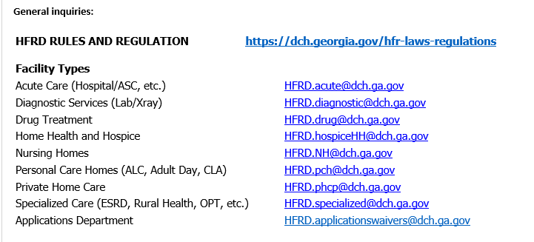

Healthcare Facility Regulation (HFR)- proxy forms/find a facility/complaints
https://dch.georgia.gov/hfr-laws-regulations

Fingerprint law/GCHEXS-
Georgia Criminal Background Check System (GCHEXS) | Georgia Department of Community Health

*DO NOT USE GCHEXS FOR SFC CAREGIVER CHECKS OR CASE MANAGEMENT

____________________________________________________________________

EDWP Referral Process- AAA contact information-
https://aging.georgia.gov/locations

Online referral system for CCSP referrals to the appropriate AAA- link below

https://hssgaprod.wellsky.com/assessments/?WebIntake=2CBCF6CD-9412-4839-8EF8-5864FA6BA0F9

*The link above is is the best way for providers to submit 3rd party referrals if they aren’t sure where they need to go.

ATLANTA
For Providers: ccspintake@atlantaregional.org
For clients and caregivers: 404-463-3333.
CSRA 888-922-4464
Coastal 800-580-6860
Georgia Mountains (Legacy Link) 855-266-4283
Heart 888-367-9913
Middle 888-548-1456
NE 800-474-7540
NW 800-759-2963
River Valley (706) 256-2900
Southern 888-732-4464
SOWEGA 800-282-6612
Three Rivers 866-854-5652
* 866-552-4464, Option 2
Policy Revisions included in the Oct 2022 (SFY 23) Edition of the EDWP Policy Manuals: Attached

Network Meeting attendance-
EDWP Provider Network Meetings consists of statewide meetings in the form of a webinar that are hosted by the Atlanta Regional Commission (ARC).
The next meeting is scheduled for 11/16/22 and 2/15/23. Providers must go to https://www.empowerline.org/for-professionals/medicaid-elderly-and-disabled-waiver-providers-meeting-information/ to register for each meeting ahead of time. Once registered, each provider will receive a confirmation e-mail that includes the link to join the webinar at the specified time and date.
All network meeting information and presentations will be placed on the ARC Network Meeting webpage.
Policy requires the attendance of two (2) network meetings per FISCAL (July 1 – June 30) year. Gen Services Manual Pg. VI-14. Corrective action can be applied for those providers who are not in compliance.
*Network meeting reminders will ONLY be sent to agencies that have registered at the site to receive the reminders. We encourage all providers to register their email address at the registration site so that they will receive the reminders for themselves.

The web-x format has the capability for DCH to track the time of logging on and off of the web-x for each provider. You must participate in the full web-x to receive credit for attending.

Anticipating the end of the PHE- Public Health Emergency
The PHE will be evaluated next by January 15th.

DFCS has created a new website in preparation for the end of the PHE. Here is the link: https://staycovered.ga.gov/

The website provides instructions on how members can update their contact information. Please share this with your staff.

Appendix K- Covid- Gammis Banner messages and notices-
https://www.mmis.georgia.gov-

NOTICES- ‘provider information’, ‘provider notices’

MESSAGES-‘provider information’, ‘provider messages’ – click ‘search’ for banner messsages

The latest Covid-19 guidance, including the Appendix K Application and Amendments can be found on the Georgia Medicaid website at https://medicaid.georgia.gov/covid-19 or https://dch.georgia.gov/

The Public Health Emergency has been extended for another 90 days, through October 13, 2022.
- https://aspr.hhs.gov/legal/PHE/Pages/covid19-15jul2022.aspx

EVV information-

Schedule of events- EVV Schedule of Events | Georgia Medicaid
Handouts and recordings- EVV Service Providers | Georgia Medicaid

Tellus Training Webinars- Tellus | EVV Software & Claims Processing For Home Health/Long Term Care (4tellus.com)

Email questions to……Evv.medicaid@dch.ga.gov or visit
https://medicaid.georgia.gov/georgia-electronic-visit-verification

