Policy Revisions included in the April 2022 Edition of the
CCSP and SOURCE Policy Manuals
Revision Date | Section | Description of Revision | Revision Type | Citation
04/01/2022 | 1103.1A19 Chapter 1100 CCSP and SOURCE Adult Day Health Services Manual | Updates policy regarding ADH/ALS building location conflict. | Policy Clarification/Update | DCH Policy
04/01/2022 | 1203.1 D and 1253.1D Chapter 1200 CCSP and SOURCE Alternative Living Services Manual | Updates policy to include ADH re non required attendance. | Policy Clarification/Update | DCH Policy
04/01/2022 | 1203.2 A and 1253.4A Chapter 1200 CCSP and SOURCE Alternative Living Services Manual | Updates policy regarding ADH/ALS building location conflict. | Policy Clarification/Update | DCH Policy
04/01/2022 | 1253.2A Chapter 1200 CCSP and SOURCE Alternative Living Services Manual | Removes policy for ALS F re PSA enrollment area for home registration. Allows contracts per home address. Adds policy to limit F Management and home contract length to 18 months, renewed annually. | Policy Clarification/Update | DCH Policy
04/01/2022 | 1407 CCSP and SOURCE Personal Support/Consumer Direction/Structured Family Care | Updates policy regarding SFC caregiver eligibility. | Policy Clarification/Update | DCH Policy
04/01/2022 | 604.1A4 Chapter 600-1000 EDWP General Services Manual | Clarifies member freedom of choice of provider. | Policy Clarification/Update | DCH Policy
04/01/2022 | Appendix D, CCSP and SOURCE Personal Support/Consumer Direction/Structured Family Care | Updates verbiage in Appendix D SFC validation tool. | Policy Clarification/Update | DCH Policy
04/01/2022 | App B Chapter 1700 CCSP and SOURCE Home Delivered Meal Services Manual | Changes from twice a month to ‘at least once a month’ re meal accumulation checks, matching 1704.6C. | Policy Clarification/Update | DCH Policy

1103.1A19 Chapter 1100 CCSP and SOURCE Adult Day Health Services Manual
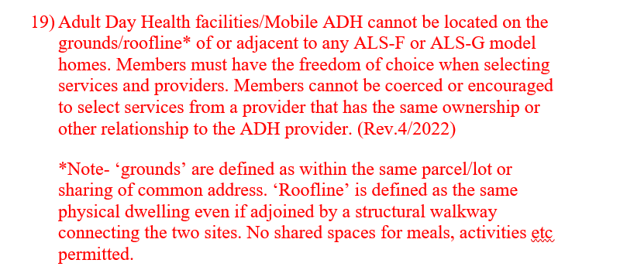

1203.1 D and 1253.1D Chapter 1200 CCSP and SOURCE Alternative Living Services Manual
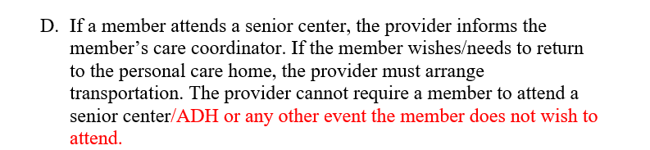

1203.2 A and 1253.4A Chapter 1200 CCSP and SOURCE Alternative Living Services Manual
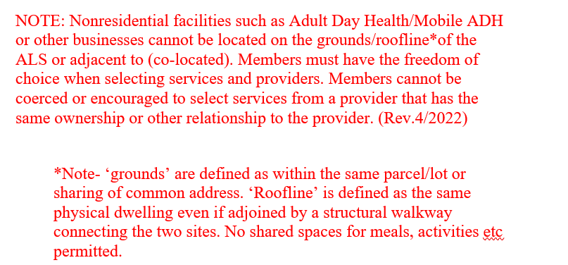

1253.2A Chapter 1200 CCSP and SOURCE Alternative Living Services Manual
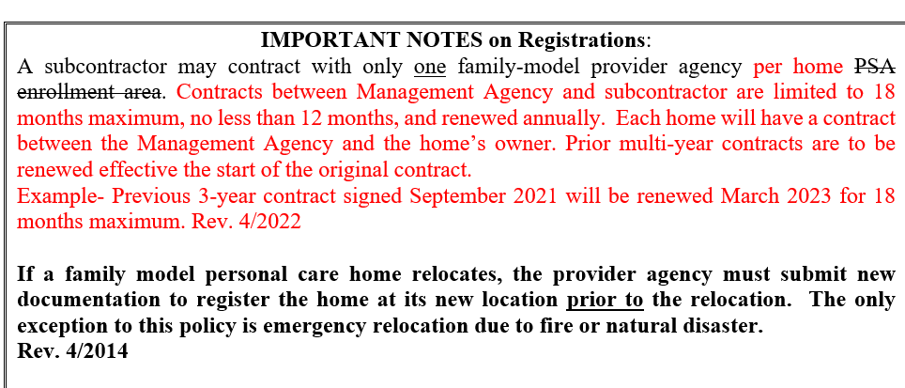

1407 CCSP and SOURCE Personal Support/Consumer Direction/Structured Family Care
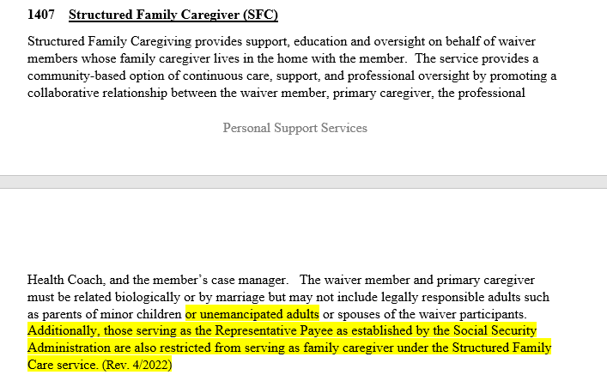

604.1A4 Chapter 600-1000 EDWP General Services Manual
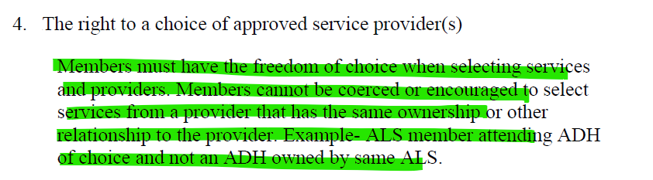

Appendix D, CCSP and SOURCE Personal Support/Consumer Direction/Structured Family Care
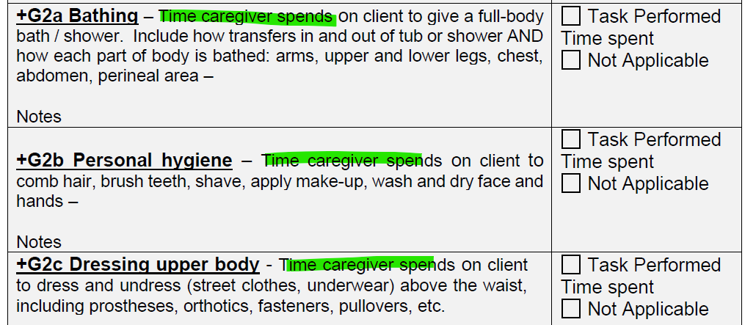

App B Chapter 1700 CCSP and SOURCE Home Delivered Meal Services Manual
Write in # of meals delivered per day. Bulk delivery appropriate on single days. IE…7 or 14. Provider signature attests to member initials noted re delivery of daily or bulk meals. Document non-deliveries; non-consumption of food by member; refrigerator/freezer/shelf meal accumulation/cooking equipment checks at least once a month twice a month; content of nutrition and/or counseling information (indicate whether the case management was notified)

