Policy Revisions included in the October 2021 Edition of the
CCSP and SOURCE Policy Manuals
Revision Date | Section | Description of Revision | Revision Type | Citation
10/01/2021 | 1405 CCSP and SOURCE Personal Support/Consumer Direction/Structured Family Care | Updates policy to reference 1009 of the General Services Manual regarding rounding rule addition. Updates policy with links to Georgia’s Lifeline Assistance and Link-Up Georgia. | Policy Clarification/Update | DCH Policy
10/01/2021 | 1406 CCSP and SOURCE Personal Support/Consumer Direction/Structured Family Care | Updates policy re annual TB screening for Cd Pss employees. Provides a link to the needed document. Updates reference re EVV for CD PSS. | Policy Clarification/Update | DCH Policy
10/01/2021 | 1406/1407.2 (8)/1407.4 (5)/ 1407.8 (1) CCSP and SOURCE Personal Support/Consumer Direction/Structured Family Care | Updates policy to remove reference to GCHXS for Cd PSS and SFC caregivers and adds reference to 105.13 and definitions Part I Policies and Procedures for Medicaid/Peachcare for Kids Policy Manual. | Policy Clarification/Update | DCH Policy
10/01/2021 | 1407.2 (14) CCSP and SOURCE Personal Support/Consumer Direction/Structured Family Care | Update policy to add an appendix D document requirement with each new/existing SFC caregiver request. | Policy Clarification/Update | DCH Policy
10/01/2021 | 1407.3 (3) CCSP and SOURCE Personal Support/Consumer Direction/Structured Family Care | Updates policy to add an appendix D document requirement for SFC ADL and relative validation. | Policy Clarification/Update | DCH Policy
10/01/2021 | 1407.4 (2) CCSP and SOURCE Personal Support/Consumer Direction/Structured Family Care | Updates policy to add an appendix D document requirement for SFC ADL and relative validation. | Policy Clarification/Update | DCH Policy
10/01/2021 | 1407.6 (4) CCSP and SOURCE Personal Support/Consumer Direction/Structured Family Care | Clarifies Medicaid Hospice aide and SFC combination. | Policy Clarification/Update | DCH Policy
10/01/2021 | 1407.7 (1) CCSP and SOURCE Personal Support/Consumer Direction/Structured Family Care | Updates policy re frequency of SFC member attending ADH. | Policy Clarification/Update | DCH Policy
10/01/2021 | 1407.7 (3) CCSP and SOURCE Personal Support/Consumer Direction/Structured Family Care | Clarifies Medicaid and Medicare Skilled nursing and SFC combination. | Policy Clarification/Update | DCH Policy
10/01/2021 | 602.1B Chapter 600-1000 General Services Manual | Updates policy regarding referral suspensions related to unsubmitted reports. | Policy Clarification/Update | DCH Policy
10/01/2021 | 1009 Chapter 600-1000 General Services Manual | Adds policy regarding rounding rules. | Policy Clarification/Update | DCH Policy

Pss 1405

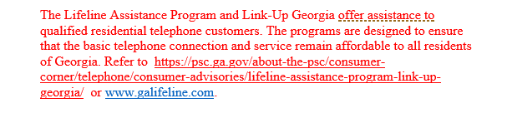

Pss 1406/ SFC 1407

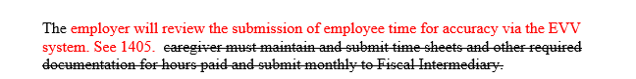

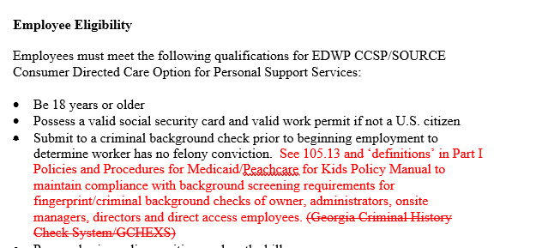

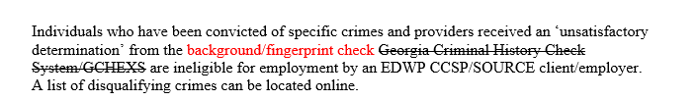

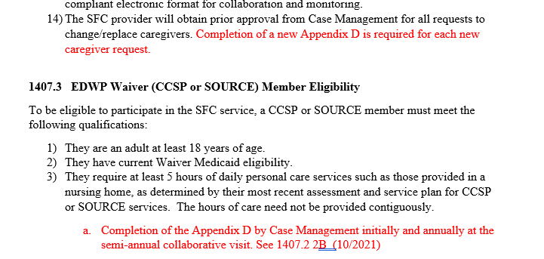

1407 SFC

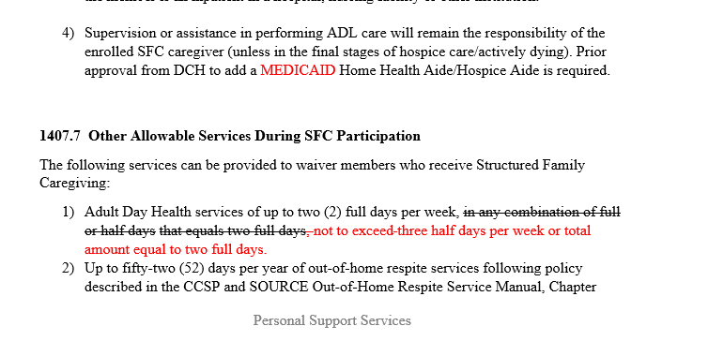

Gen Services 602.1 -reasons to suspend referrals

Gen Services 1009

