WAIVER | WAIVER Specialist
EDWP Provider Specialist  ICWP Lead | Vonnie Stelly  VStelly@dch.ga.gov 404-656-7875
EDWP Provider Specialist  NOW/COMP Lead | Laura Hudlow  Laura.Hudlow@dch.ga.gov 404-463-5073
EDWP Case Management Specialist  CCSP Lead | Jill Crump  Jill.Crump@dch.ga.gov 404-657-7228
EDWP Case Management Specialist  SOURCE Lead | Carolyn Porter, RN  Carolyn.Porter@dch.ga.gov 404-463-1104
EDWP Provider Specialists  (waiver enrollment, changes, updates, buyouts etc) | Atiya Hasan  Ahasan@dch.ga.gov 404-463-1897  AND  Laura Hudlow  Laura.Hudlow@dch.ga.gov 404-463-5073
EDWP changes/questions/ALS F Registrations | ccsp.messages@dch.ga.gov
GAPP | Sharon Collins  scollins@dch.ga.gov 404-657-7882
Section Manager | Vacant
Director, Program and Community Support | Rebecca Dugger  rdugger@dch.ga.gov 404-463-0551
PA Management/Claims Resolution | Donna Elrod  404-463-1898 Donna.elrod@dch.ga.gov

Appendix K- Covid- Gammis Banner messages and notices-
https://www.mmis.georgia.gov-

NOTICES- ‘provider information’, ‘provider notices’

MESSAGES-‘provider information’, ‘provider messages’ – click ‘search’ for banner messsages

Email Account- Medicaid.PCKCOVID19@dch.ga.gov

The latest Covid-19 guidance, including the Appendix K Application and Amendments can be found on the Georgia Medicaid website at https://medicaid.georgia.gov/covid-19 or https://dch.georgia.gov/
Latest FAQ- https://www.medicaid.gov/state-resource-center/downloads/covid-19-faqs.pdf

EVV information- CONDUENT

Schedule of events- EVV Schedule of Events | Georgia Medicaid
Handouts and recordings- EVV Service Providers | Georgia Medicaid

Tellus Training Webinars- Tellus | EVV Software & Claims Processing For Home Health/Long Term Care (4tellus.com)

Email questions to……Evv.medicaid@dch.ga.gov or visit
https://medicaid.georgia.gov/georgia-electronic-visit-verification

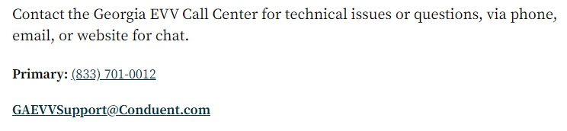

The Georgia Department of Community Health, HCBS Waiver incident reporting system:

The HCBS Incident Report can be accessed at https://medicaid.georgia.gov/ under the Provider links section at the bottom of the page.
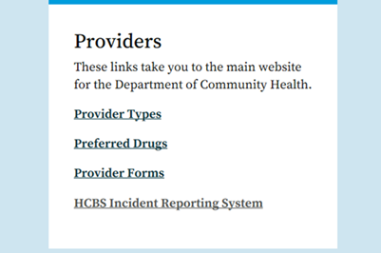

Additionally, we have a resources page to assist in training agency staff.

Link to resource page:
https://medicaid.georgia.gov/programs/all-programs/waiver-programs/hcbs-incident-reporting-system-resources

For questions or technical assistance, please reach out to the HCBS Waiver Unit at: HCBS.IncidentReports@dch.ga.gov.

Other Contacts

- DXC, 1-800-766-4456

- Provider Enrollment enrollment@dch.ga.gov

  - Provider Enrollment Manager: Leslie Austin 404-657-4865 laustin@dch.ga.gov

  - Provider Enrollment Director: Nichole Thompson 404-651-5191 Nthompson1@dch.ga.gov

- Revalidation, revalidationenrollment2@dch.ga.gov

- CVO, 1 800-766-4456

Personal Care Homes/HFR (ALC, Adult Day, CLA) | HFRD.pch@dch.ga.gov
Private Home Care/HFR | HFRD.phcp@dch.ga.gov

Finding a list of active medicaid providers in Ga
https://dch.georgia.gov/ click on ‘providers’ and ‘provider directory’

- Healthcare Facility Regulation (HFR)- proxy forms/find a facility/complaints
https://dch.georgia.gov/hfr-laws-regulations

Elaine Wright- ehwright@dch.ga.gov- Private Home Care and PCH
Shirley Rodrigues serodrigues@dch.ga.gov PCH
Michelle Robinson Michelle.Robinson1@dch.ga.gov PHC

Fingerprint law/GCHEXS- Effective October 1, 2019, facilities shall be required to use GCHEXS for fingerprint criminal background checks of owners, administrators, onsite managers, directors, AND direct access employees. See link below for more information.
Georgia Criminal Background Check System (GCHEXS) | Georgia Department of Community Health
Policy Revisions included in the July 2021 (SFY 21) Edition of the EDWP Policy Manuals: Attached

Network Meeting attendance-
EDWP Provider Network Meetings have transitioned to a new DCH Network Meeting Format,. The format consists of statewide meetings in the form of a webinar that will be hosted by the Atlanta Regional Commission (ARC).
The next meetings are scheduled for 11/17/21, 2/16/22, and 5/18/22. Providers must go to Medicaid Elderly and Disabled Waiver Providers – Existing Provider Meeting Information - Empowerline to register for each meeting ahead of time. The date is pulled down from the dropdown list. All of the rest of the dates for the fiscal year are listed. Once registered, each provider will receive a confirmation e-mail that includes the link to join the webinar at the specified time and date.
All network meeting information and presentations will be placed on the ARC Network Meeting webpage located at https://www.empowerline.org/for-professionals/medicaid-elderly-and-disabled-waiver-providers-meeting-information/
Policy requires the attendance of two (2) network meetings per FISCAL (July 1 – June 30) year. Gen Services Manual Pg. VI-14. Corrective action can be applied for those providers who are not in compliance.
*Network meeting reminders will ONLY be sent to agencies that have registered at the site to receive the reminders. We encourage all providers to register their email address at the registration site so that they will receive the reminders for themselves.

The web-x format has the capability for DCH to track the time of logging on and off of the web-x for each provider. You must participate in the full web-x to receive credit for attending.

*PROVIDER member referrals and follow-up need submitted to your specific region’s AAA.

ATLANTA
For Providers: ccspintake@atlantaregional.org
For clients and caregivers: 404-463-3333.
CSRA 888-922-4464
Coastal 800-580-6860
Georgia Mountains (Legacy Link) 855-266-4283
Heart 888-367-9913
Middle 888-548-1456
NE 800-474-7540
NW 800-759-2963
River Valley (706) 256-2900
Southern 888-732-4464
SOWEGA 800-282-6612
Three Rivers 866-854-5652

AAA contact information-
https://aging.georgia.gov/locations

Online referral system for CCSP referrals to the appropriate AAA- **** NEW

Quick Screen and Intake (wellsky.com) - link

