

NOTE: Advanced notice to HDM providers is required by Case Management when members will transition to Alternative Living Services (ALS) and discharge from the HDM option. Collaboration with the HDM provider will ensure payment for meals delivered has paid based on consumption before ALS can begin. (4/2021)



NOTE: *Advanced notice to HDM providers is required when transitioning to SFC/ALS and discharging from the HDM option. Collaboration with the HDM provider will ensure payment for meals delivered has paid based on consumption before SFC/ALS can begin. (1/2021, 4/2021)



NOTE: Advanced notice to HDM providers is required by Case Management when members transition to Structured Family Care (SFC) or Alternative Living Services (ALS) and discharge from the HDM option. Collaboration with the HDM provider will ensure payment for meals delivered has paid based on consumption before SFC/ALS can begin. (1/2021, 4/2021)



A subcontractor is not approved for placement of CCSP/SOURCE members until the Division has notified the Area Agency on Aging, in writing, that the home has been registered. **The Division reserves the right to delay or deny registration of any subcontractor. The Division reserves the right to terminate a contract between a provider agency and a home(s). The Division will review the documentation submitted by a home and issue its decision thereafter.**



NOTE: In December 2016, the 114th US Congress enacted the 21st Century CURES Act. Section 12006 of the Act requires States to implement Electronic Visit Verification (EVV) for Medicaid-financed Personal Care Services. The mandate contributes to Georgia Medicaid’s mission of providing access to affordable, quality health care services for Medicaid Members. EVV will help to reduce billing errors and improve claims payment accuracy as well as reduce Medicaid fraud, waste and abuse by verifying services were rendered.

Electronic Visit Verification (EVV) is a technology that automates the gathering of service information by capturing time, attendance, and care plan information entered by a home care worker at the point of care. EVV gives providers, care coordinators, and DCH access to service delivery information in real time to ensure there are no gaps in care throughout the entire course of the service plan. The technology contributes to Georgia Medicaid’s mission of providing access to affordable, quality health care services for Medicaid members.

Georgia DCH selected Tellus, [www.4tellus.com](https://gcc02.safelinks.protection.outlook.com/?url=https%3A%2F%2Fwww.4tellus.com%2F&data=04%7C01%7Cjill.crump%40dch.ga.gov%7C33020ef190e447078ac208d8d2a82f9e%7C512da10d071b4b948abc9ec4044d1516%7C0%7C0%7C637490967072444506%7CUnknown%7CTWFpbGZsb3d8eyJWIjoiMC4wLjAwMDAiLCJQIjoiV2luMzIiLCJBTiI6Ik1haWwiLCJXVCI6Mn0%3D%7C1000&sdata=%2FV9AJ2tzJ9mw1zk9Fl66Fu70tzAKiLdFSr4d%2FD%2FRKRI%3D&reserved=0), as the State selected EVV system, The state selected system is available at no cost to the Personal Support Provider/Consumer Direct member. DCH allows the provider to either select their own EVV system or use the DCH system. However, the provider is responsible for any costs associated with using the alternate EVV system.

It is the provider’s responsibility to ensure their selected EVV system meets both DCH and the 21st Century Cures Act requirements. More information regarding system requirements, FAQs, EVV readiness and training can be obtained at **[https://medicaid.georgia.gov/programs/all-programs/georgia-electronic-visit-verification-evv/evv-service-providers](https://gcc02.safelinks.protection.outlook.com/?url=https%3A%2F%2Fmedicaid.georgia.gov%2Fprograms%2Fall-programs%2Fgeorgia-electronic-visit-verification-evv%2Fevv-service-providers&data=04%7C01%7Cjill.crump%40dch.ga.gov%7C03309eaddaf34d71912508d8d2a21bf3%7C512da10d071b4b948abc9ec4044d1516%7C0%7C0%7C637490940998231341%7CUnknown%7CTWFpbGZsb3d8eyJWIjoiMC4wLjAwMDAiLCJQIjoiV2luMzIiLCJBTiI6Ik1haWwiLCJXVCI6Mn0%3D%7C1000&sdata=WfdQWAdQKyyAwED0DR6%2ByETke27TgzcZCXPoIIGaMTo%3D&reserved=0).** The Georgia Department of Community Health (DCH) will implement EVV for Personal Support Services and Consumer Direction on July 1, 2021.



* Complete an initial ~~and annual~~ physical that includes TB screening (documentation of TB screening in the past 3 months will be accepted) and symptoms screening yearly per CDC guidelines, verified by the employer.
* Understand and agree to comply with the Personal Support Consumer Directed Services option program requirements and policies, rights, and responsibilities and confidentiality requirements.

Effective July 1, 2019, all requests for approval of payment to a live-in family caregiver will be approved only under the Structured Family Caregiver program (see 1407). Approved relative caregiver cases (living outside of the member’s home) must be reaffirmed and approved annually. Rev. 04/2021.



14)The SFC provider will obtain prior approval from Case Management for all requests regarding new caregiver changes.



* 1. ERS providers are not required to replace a system unless there is a malfunction/ defect in the current unit, unit upgrade by the provider agency or act of nature issue with the existing unit. If the unit is damaged or lost by the member/caregiver, neither the provider nor Medicaid will be responsible for the cost of a new unit/install. A member remaining active in the waiver program but requesting ERS service termination and then return of the ERS service within a 12 month period (excluding a temporary nursing home stay) will be subject to the cost of the second installation fee.



1. Providers seeking ~~service area~~ expansion of county coverage for an existing service must have been EDWP (CCSP and SOURCE) providers for a minimum of twelve (6) ~~(12)~~ months.



0TMedicaid reimbursement for the current provider will terminate on the effective date of the sale. The new provider must complete a change of ownership/CHOW application with new payee ID/EIN and provide the Department with appropriate banking information for proper Medicaid reimbursement. Upon approval of the CHOW, Medicaid reimbursement will be effective the date of ownership and approval to enroll in the EDWP (CCSP and SOURCE) if the following conditions are met:



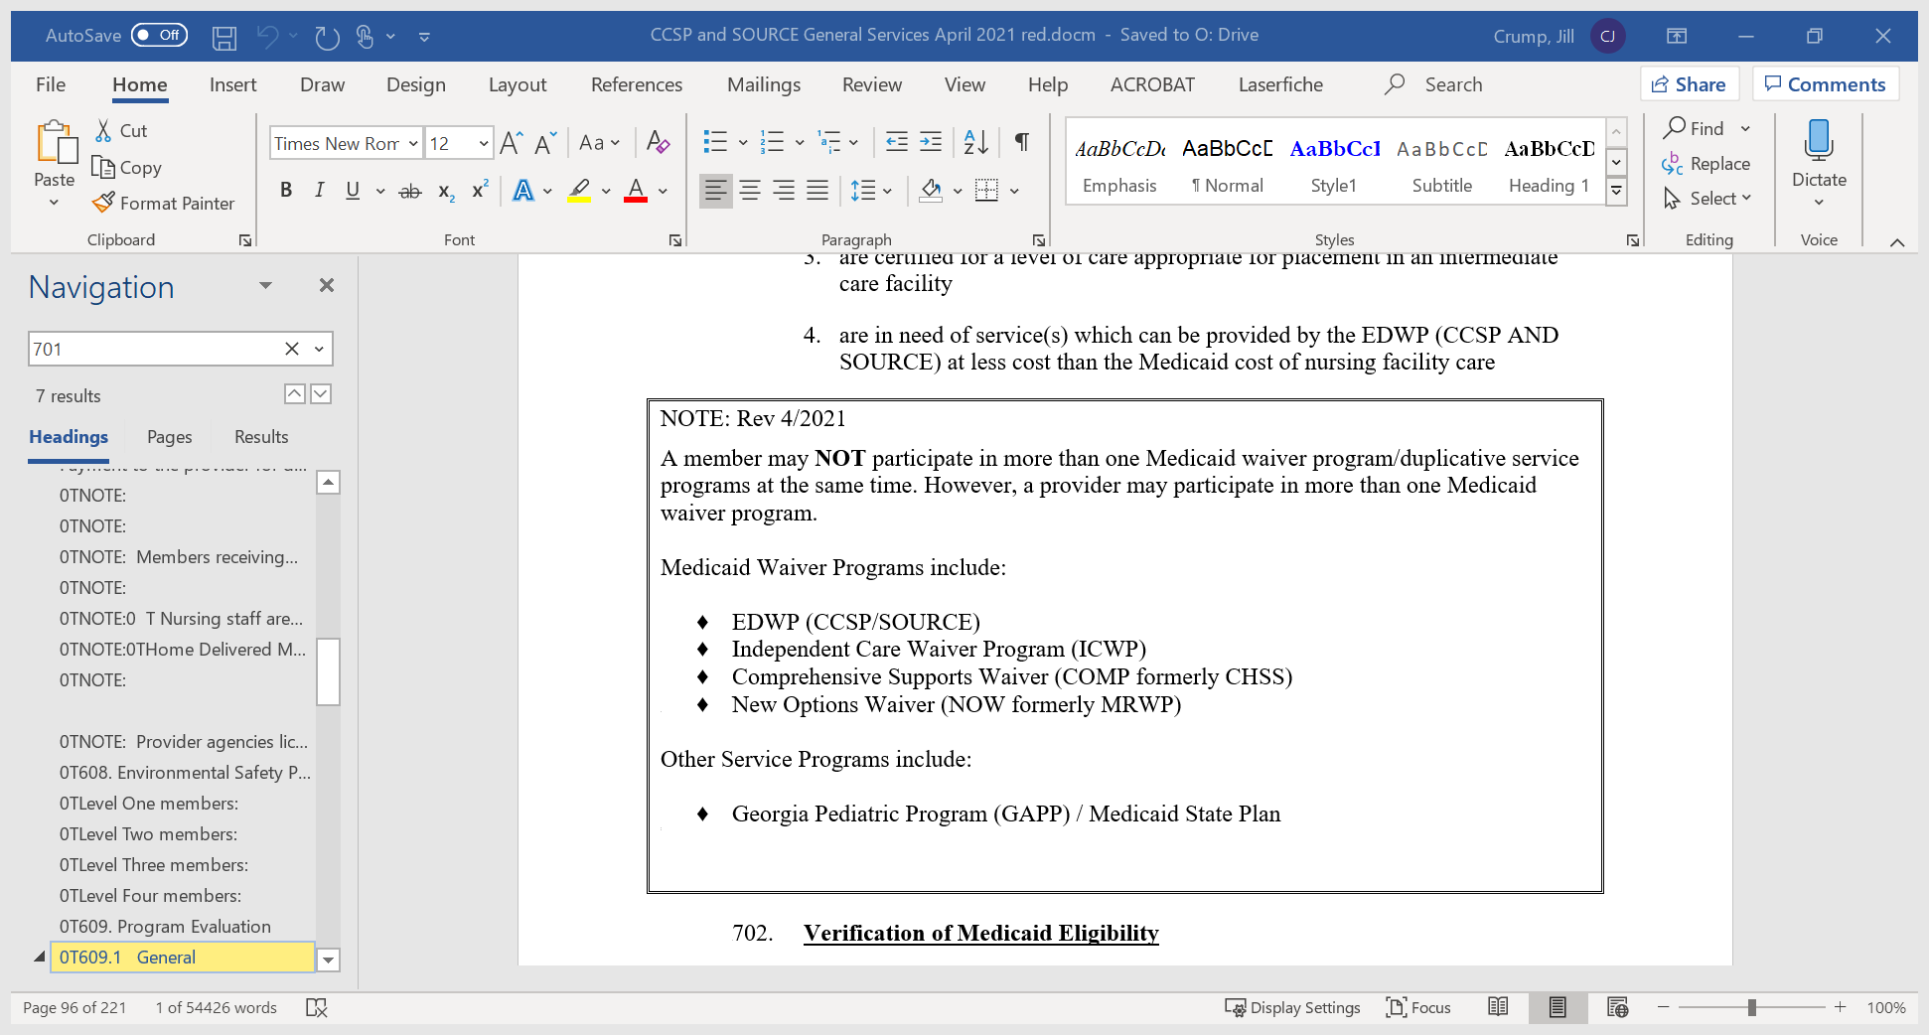







**NOTE: For SNS RN/LPN ~~personal support~~ services for SOURCE, see the SOURCE documents manual for the National Codes and Rates ~~Appendix DD of the SOURCE Manuals~~ ~~for rates~~ for T1030 and T1031 ~~T1021~~, ~~including all modifiers~~.**



##### Non-Emergency Medical Transportation

**ModivCare**

**(*formerly LogistiCare)***