CCSP Network Meeting Webinar
Registration

The Statewide Network Meeting Webinar can be found at the Atlanta Regional Commission’s Empowerline Website:
The Link to the page is below:
https://www.empowerline.org/for-professionals/elderly-disabled-waiver-providers/

The page looks like this:
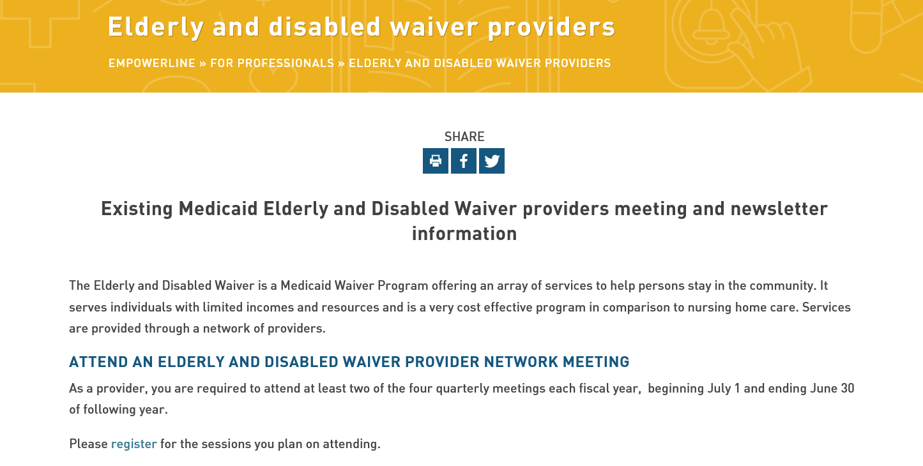
Once on the page, you click here to register for the webinar

Please make sure you register your email address at the very bottom of the page to receive reminders and notifications:
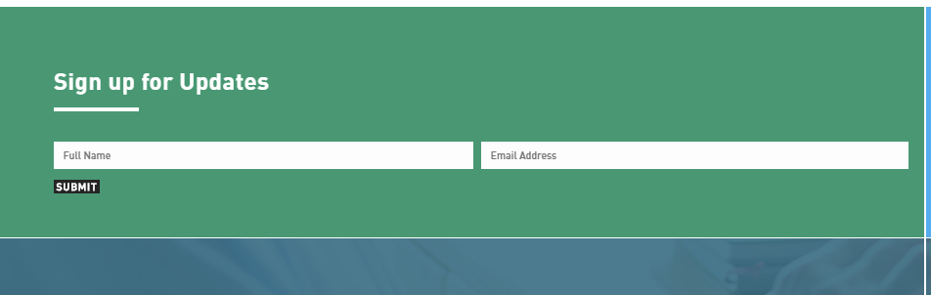

The dates for FY20 are:
You can register for all dates in advance.

When you click the registration button, it will take you to a page like the one below. You will be required to fill out the complete form:

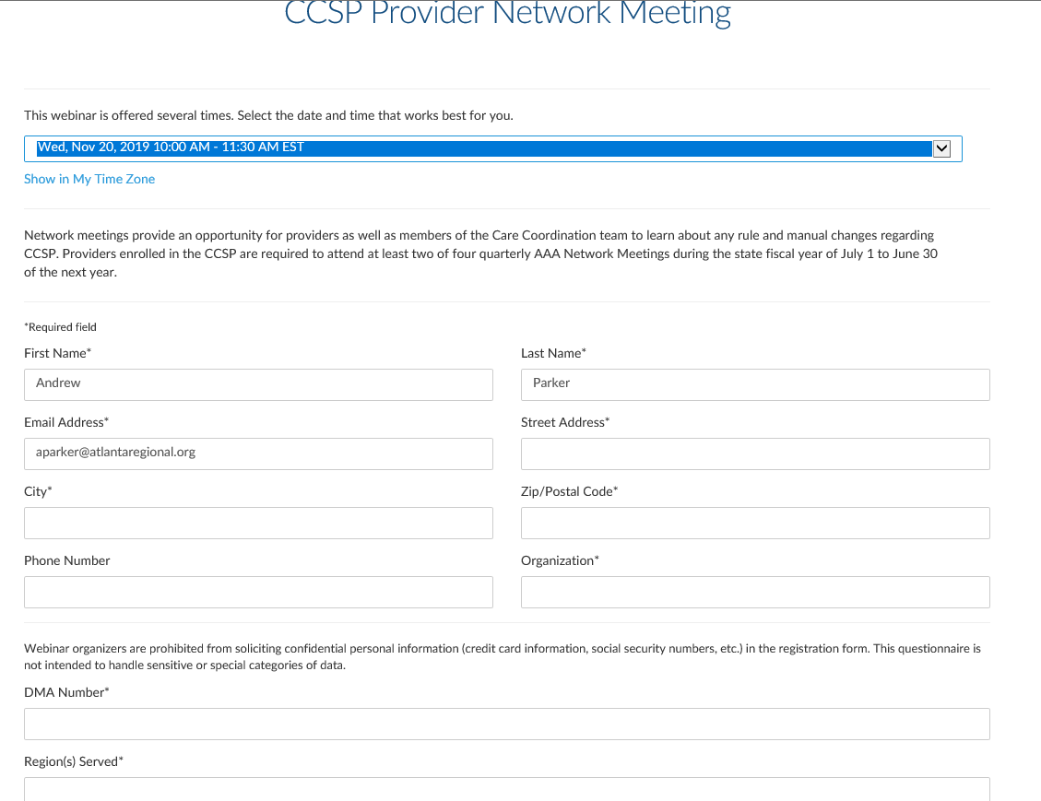

Once you register, you can add the event to your calendar:
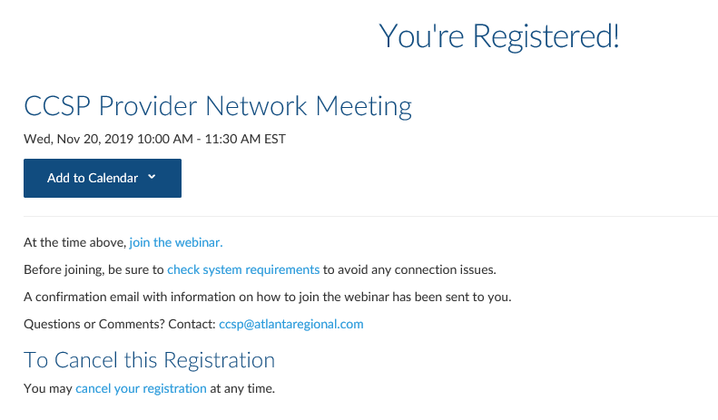
At the date and time of the webinar, you will
Click the link to join the webinar:
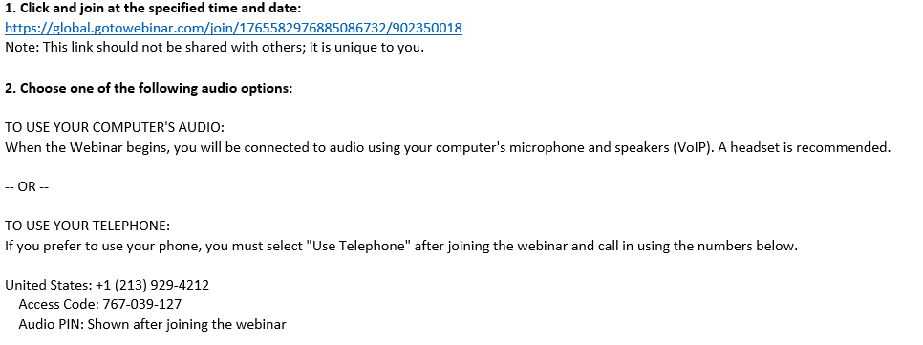

Once you have joined the webinar, it will record your participation in the webinar and will capture:
- How long you stayed on the webinar
- Any questions you submitted
- Your Provider Name and DMA #
  - Your DMA number is the Provider number assigned to you by DAS.
You can contact Andrew Parker at the Atlanta Regional Commission if you have any questions:
Andrew Parker
aparker@atlantaregional.org
ccsp@atlantaregional.org
470-378-1638

